**GitHub Account Creation**

**Step 1:** First I opened the sign up page for github.



**Step 2:** Then I got signed up to github by giving all my required details.

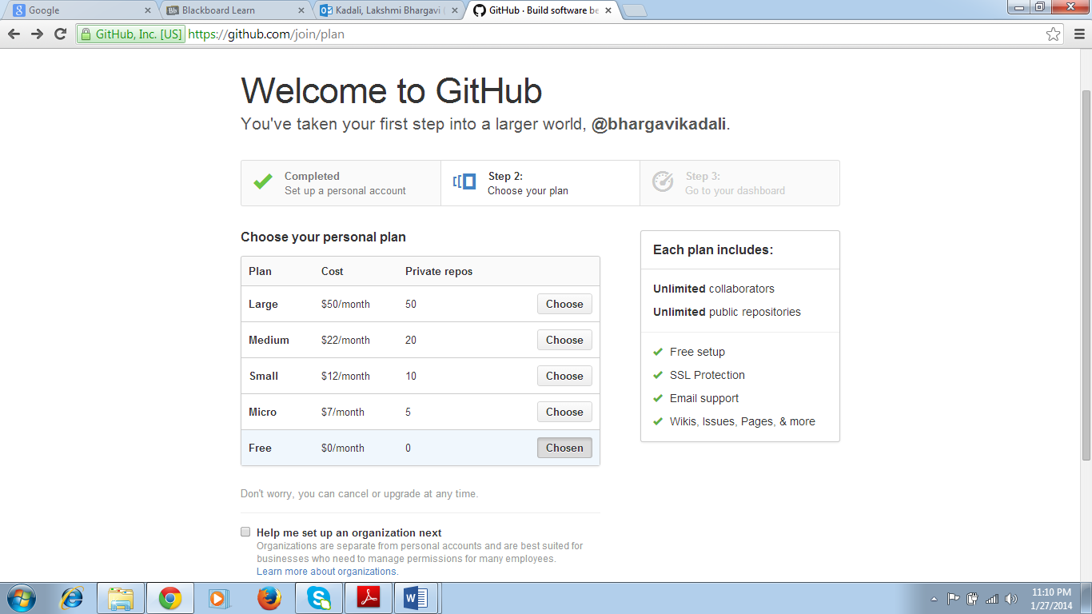

**Step 3:** This is my github account Home page after signing up.

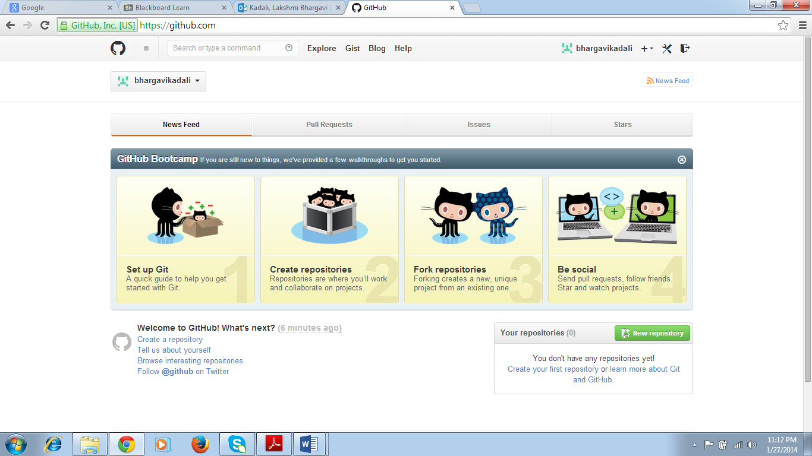

**Step 4:** Finally, I posted my github ID in the given link.

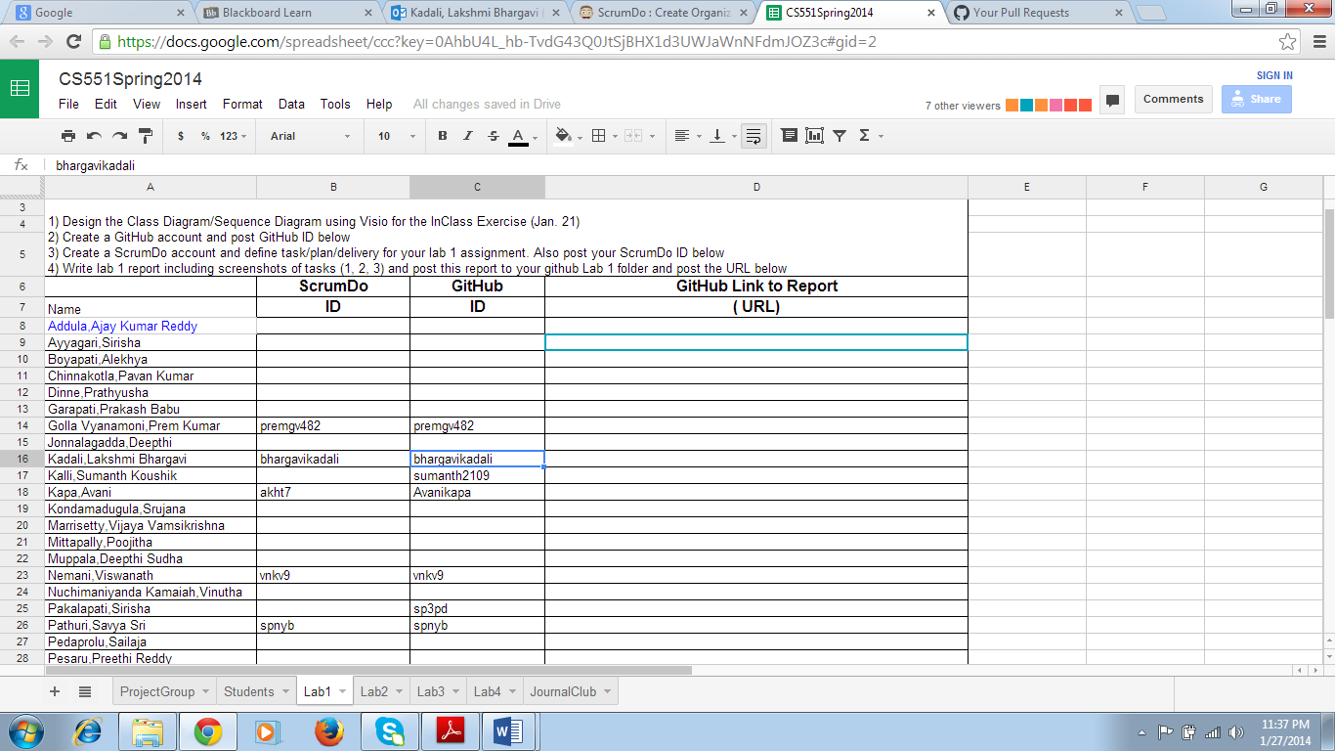

**ScrumDo Account Creation**

**Step 1:** First, I opened the signup page of ScrumDo.

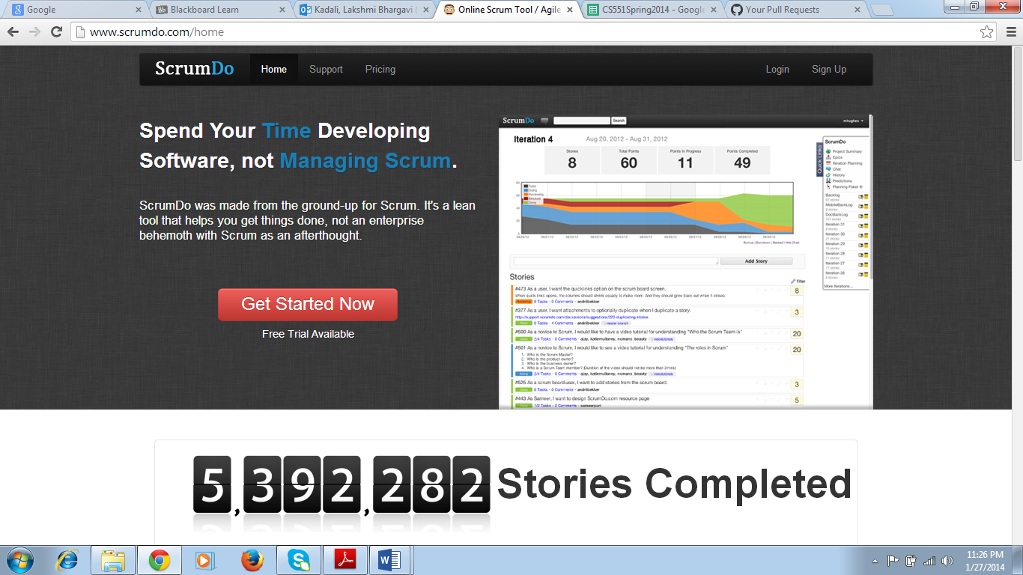

**Step 2:** I then gave me sign up details and created my ScrumDo account.

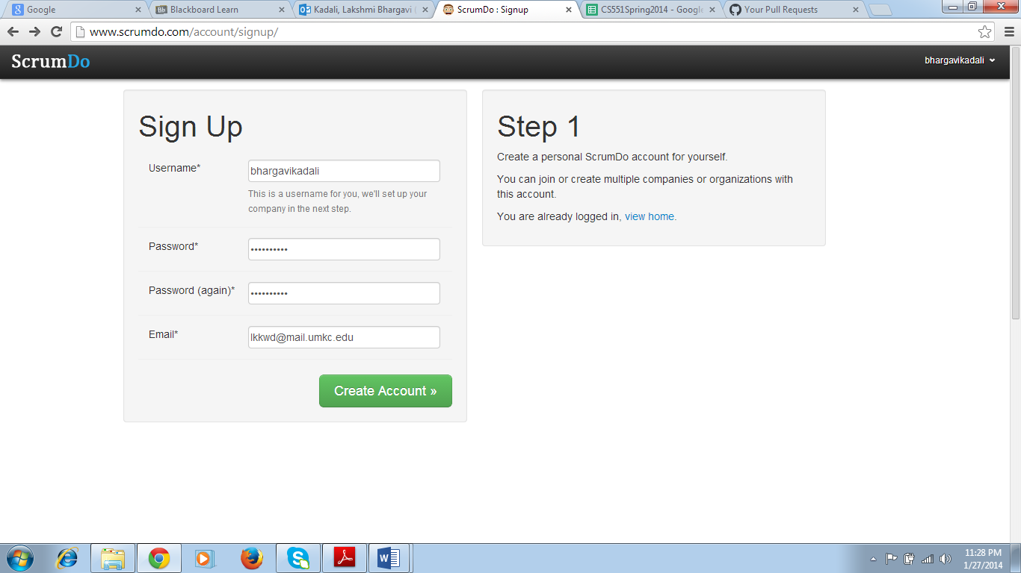

**Step 3:** This is my ScrumDo account. I created a project called “ASE”.

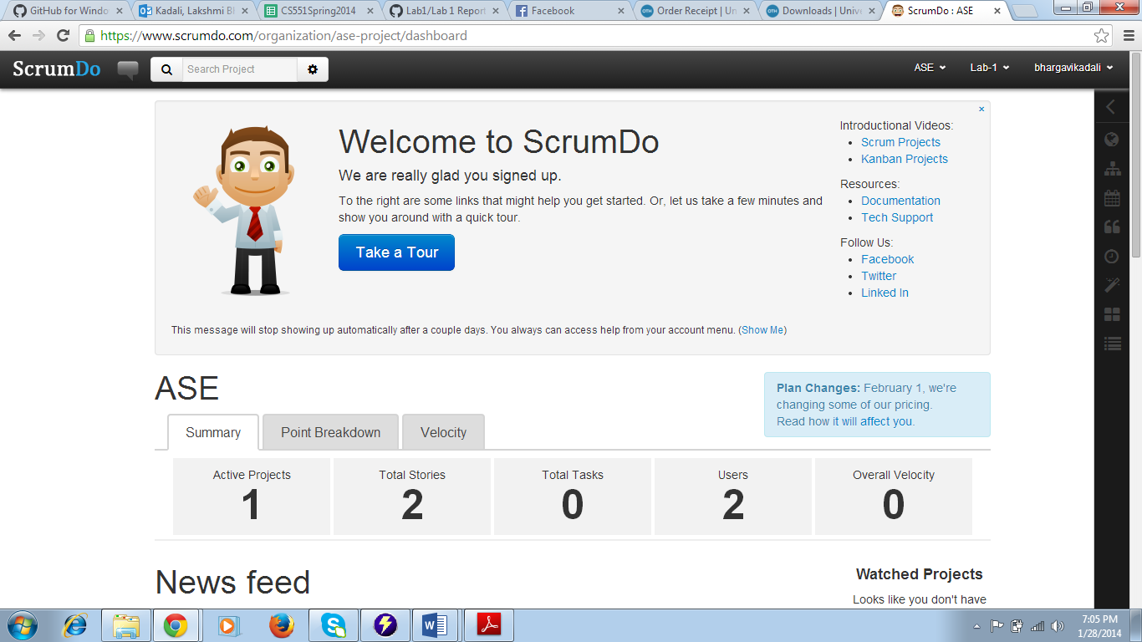

**Step 4:** I then created a Backlog and described a story.

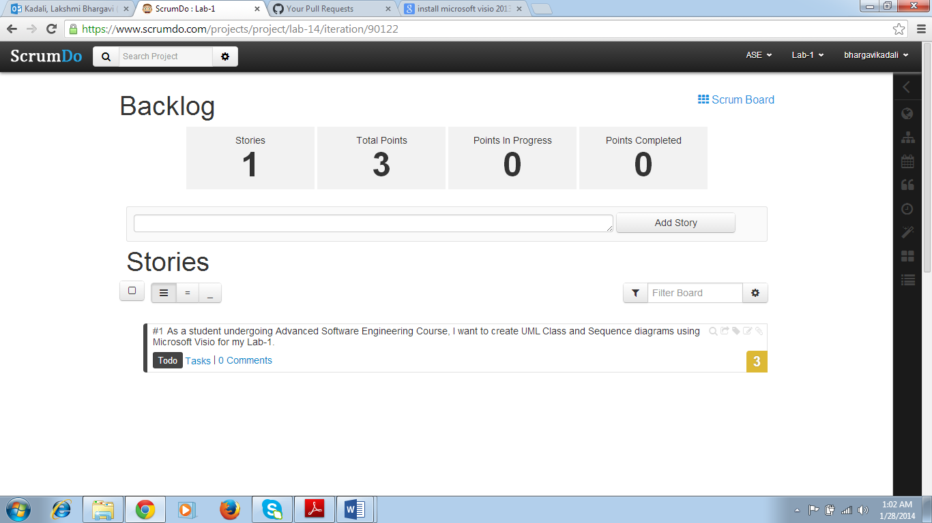

**Step 5:** I even created iteration-1 and described a story about the task that I should accomplish for my Lab-1.

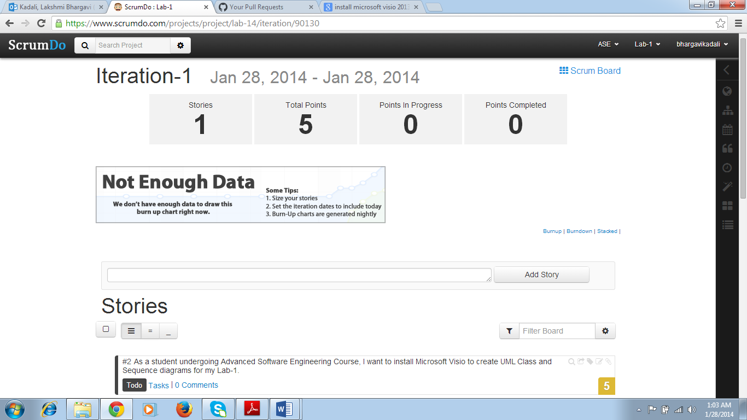

**Step 6:** I then moved the story from Backlog to Iteration-1.

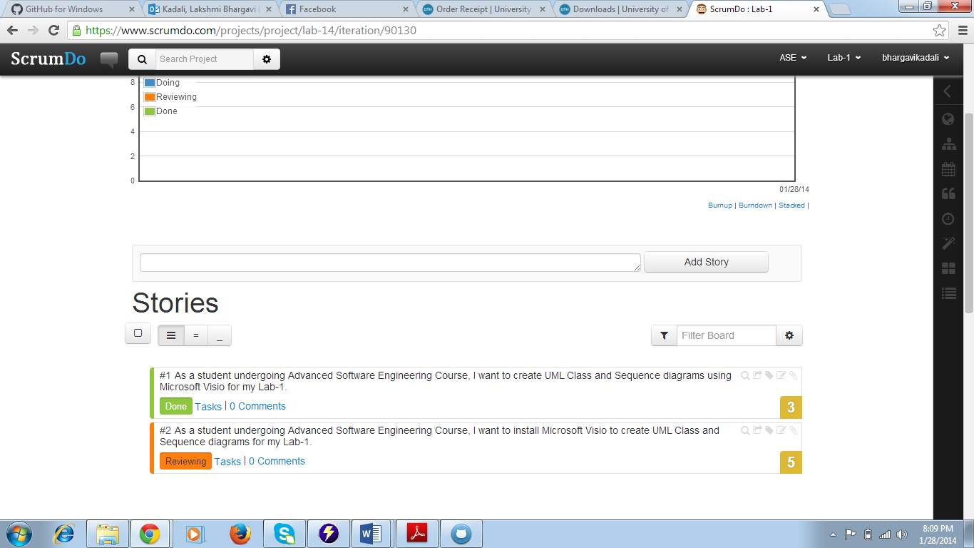

**Step 7:** I added a task of downloading Microsoft Visio for creating Class and Sequence diagrams for my Lab-1 into ScrumBoard.

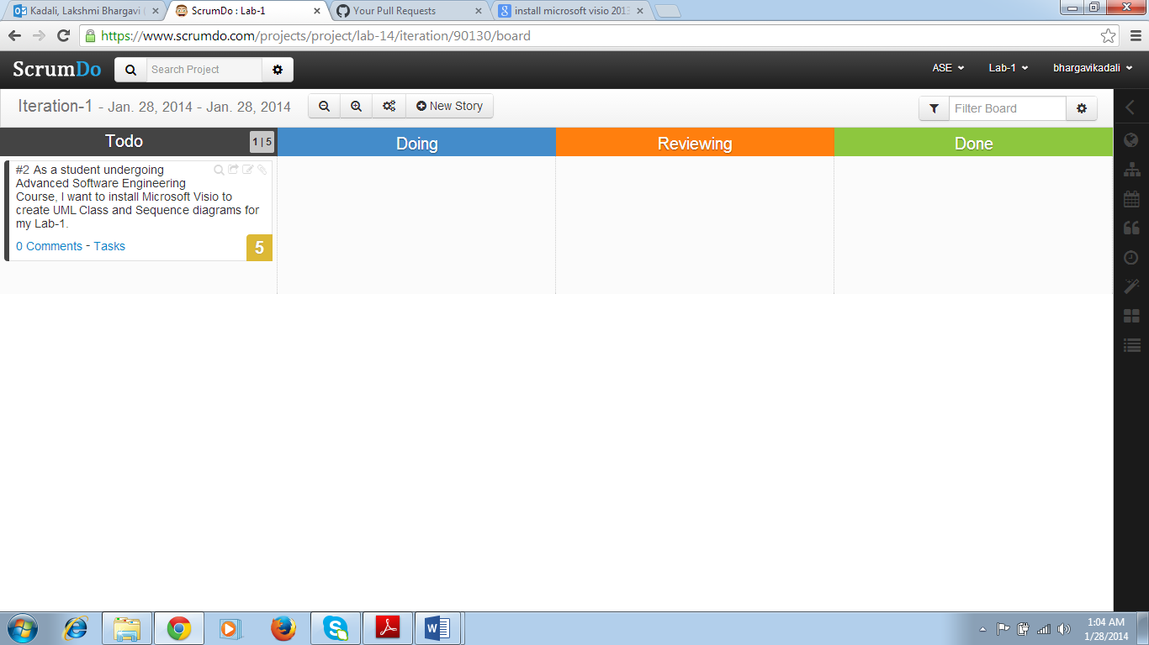

**Step 8:** I then updated my task in Scrum Boardfrom Todo to Doing. In this way the task is completed by moving it forward (with respect to the status of task) accordingly.

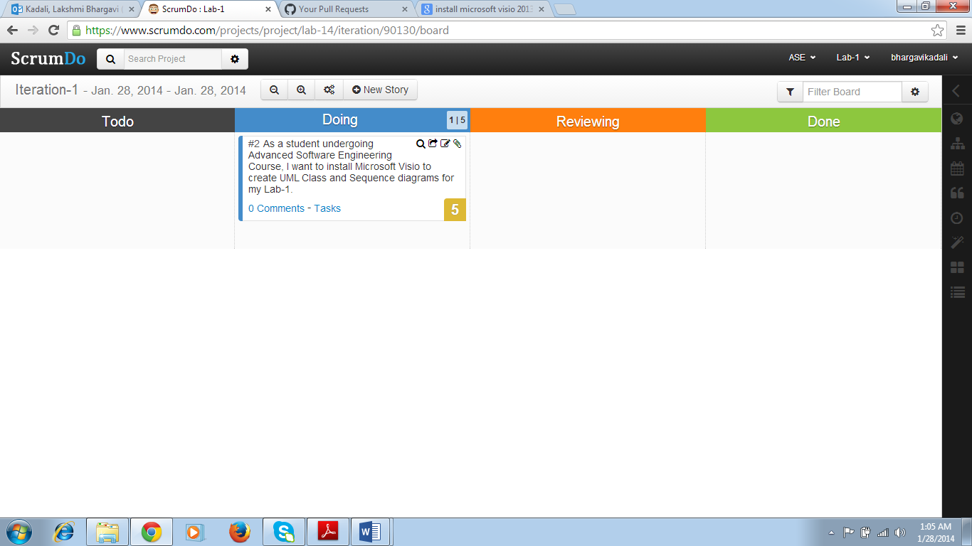

**Step 9:** I then created another iteration (Iteration-2) and added a story of drawing Class and Sequence diagrams for my Lab-1 using Visio.

